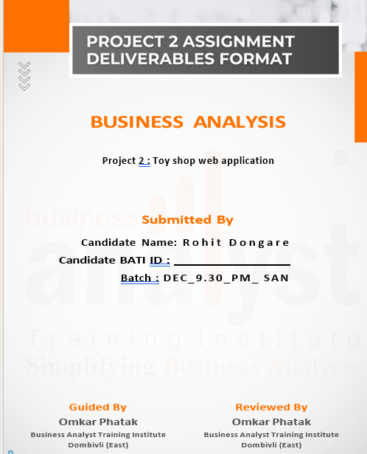

Contents

1. Project scope document: 3
2. Modules: 8
3. Key features: 10
4. Technology and framework: 13
5. Proof of concept: 14
6. Project estimation portal: 21
7. Project team: 26
8. Business requirement document (BRD): 32
9. Software requirement specifications: 44

# Toy shop web application:

# Project scope document:

|  |  |  |  |  |  |  |
| --- | --- | --- | --- | --- | --- | --- |
| **Product Features of Customer** | | | | | | |
| **Category** | **Section** | | | **Actions** | | **Sub-Actions** |
| **Authentication** | Login | | | Login | | Enter credentials (email/username, password) & Authenticate. |
| **Purchase** | Purchase the product | | | Buy now | | pay the money and add address |
| **Registration** | Register | | | Register | | Submit registration details. |
| **Refund** | Demand for refund | | | Demand for refund | | Enter refund reason |
| **Profile** | Edit Profile | | | Edit Profile | | Change the necessary details and submit |
| **Order** | Create/Update/Delete Booking | | | Create/Update/Delete Booking | | Edit the booking entter necessary details. |
| **Payment** | Create/Update Payement | | | Create/Update Payement | | Enter payment method and proceed. |
| **Log out** | Log out | | | Log out | | Press the log out button and confirm. |
| **Cart** | Add product to cart | | | Add product to cart | | Add n number of products at same time and purchase it. |
| **View** | View products | | | View products | | Home page you can view the products. |
| **Feedback** | Feedback | | | Feedback | | Add feedback to textbox and submit. |
| **Contact** | Contact delivery boy by call | | | Contact delivery boy by call | | You can chat with customer support. |
| **Cancellation** | Cancel Order | | | Cancel Order | | Enter the reason for cancellation and cancel the order. |
|  |  | | |  | |  |
| **Product Features of Admin** | | | | | | |
| **Category** | | **Section** | **Actions** | | **Sub-Actions** | |
| **Authentication** | | Login | Login | | Enter credentials (email/username, password) & Authenticate. | |
| **Transactions** | | Track transactions | Transactions | | Click on view transactions. | |
| **Registration** | | Register | Register | | Submit registration details. | |
| **Provide promocode** | | Provide promocode | Go on promocode option | | Enter credentials. | |
| **Profile** | | Edit Profile | Edit Profile | | Change the necessary details and submit | |
| **Holiday** | | Create/Update/Delete Holiday | Create/Update/Delete Booking | | Edit the holiday entter necessary details. | |
| **Payment** | | Create/Update Payement | Create/Update Payement | | Enter payment method and proceed. | |
| **Logout** | | Log out | Log out | | Press the log out button and confirm. | |
| **Roles** | | Create roles | Click on roles. | | Enter necessary details. | |
| **Product Features of Admin** | | View products | View products | | Home page you can view the products. | |
| **Feedback** | | Feedback | Feedback | | Add feedback to textbox and submit. | |
| **Purchase rate** | | User purchase rate | User purchase rate | |  | |
| **Refund** | | Update refund | Click on refund | | Enter reason for refund and refund amount. | |

|  |  |  |  |
| --- | --- | --- | --- |
| **Product Features of Customer support** | | | |
| **Category** | **Section** | **Actions** | **Sub-Actions** |
| **Authentication** | Login | Login | Enter credentials (email/username, password) & Authenticate. |
| **Read booking** | Bookings | Bookings | Read booking details |
| **Registration** | Register | Register | Submit registration details. |
| **Chat option** | Chat | Chat | Chat with customer |
| **Profile** | Edit Profile | Edit Profile | Change the necessary details and submit |
| **Mail** | Email | Email | Send mail |
| **Feedback** | Read feedback | Read feedback | Read feedback and respond. |
| **Log out** | Log out | Log out | Press the log out button and confirm. |
| **Alert** | Maintainance | Maintainance | Click on create alert. |
| **View** | View products | View products | Home page you can view the products. |

|  |  |  |  |
| --- | --- | --- | --- |
| **Product Features of Inventory support** | | | |
| **Category** | **Section** | **Actions** | **Sub-Actions** |
| **Authentication** | Login | Login | Enter credentials (email/username, password) & Authenticate. |
| **Products** | Track Number of products | Track Number of products | Click on Product details |
| **Registrations** | Register | Register | Submit registration details. |
| **Order products** | Order products | Order products | Click on order. |
| **Profile** | Edit Profile | Edit Profile | Change the necessary details and submit |
| **Holiday** | Create/Update/Delete Holiday | Create/Update/Delete Booking | Edit the holiday entter necessary details. |
| **Payment** | Create/Update Payement | Create/Update Payement | Enter payment method and proceed. |
| **Logout** | Log out | Log out | Press the log out button and confirm. |
| **Roles** | Create roles | Click on roles. | Enter necessary details. |
| **Product Features of Admin** | View products | View products | Home page you can view the products. |

|  |  |  |  |
| --- | --- | --- | --- |
| **Product Features of accounts** | | | |
| **Category** | **Section** | **Actions** | **Sub-Actions** |
| **Authentication** | Login | Login | Enter credentials (email/username, password) & Authenticate. |
| **Products** | Track Number of products | Track Number of products | Click on Product details |
| **Registrations** | Register | Register | Submit registration details. |
| **Creating Budget report** | Creating Budget report | Creating Budget report | Click on budget report. |
| **Analysing Final accounts** | Analysing Final accounts | Analysing Final accounts | Click on final accounts |
| **Providing receipt** | Providing receipt | Providing receipt | Edit the holiday entter necessary details. |
| **Paying salary** | Paying salary | Paying salary | Enter payment method and proceed. |
| **Payment history** | Payment history | Payment history | Press the log out button and confirm. |

# Modules:

**1.1 Admin module:**

Admin can access the mobile application at the back end and can perform the below-mentioned activities:

1. Create a login
2. Add, update, and delete anything (Product, role) he wants to change
3. Can access the data of customers such as name, address, or contact information
4. Check the customer order information and their payments
5. Check attendance of staff, approve or disapprove leaves
6. Add manager and receptionist to give special login access
7. Provide promo code can track the performance of employees

Update refunds and track transactions.

**1.2 Content Manager Module:**

A content manager has login access to everything at the back-end same as the owner except for deleting anything from the application. This module will be connected with the owner module so that if manager makes any changes such as changing the prices of the products it will be notified to the admin. A manager will be able to access following things:

1. Login
2. Create discounts for special customers
3. Changing the prices of the products according to the seasons
4. Check attendance of staff
5. Customer’s check-in and check-out
6. Add, edit, and manage amenity products.
7. Download daily shop business reports.

**1.3 Customer support module:**

The customer support takes care of customers offline as well as online but with limited access at the front desk to make any updates or changes. This module will be linked to the admin and manager’s module so that they can check on the activities happening at the hotel. A customer support will be able to do necessary things such as:

1. Login
2. Help customers with their queries.
3. Read feedback and create FAQ’s
4. Respond through the mail.
5. Give feedback to employees.
6. Record calls and chats. viii. Download the customer query resolution report

**1.4 Customer module:**

Customer is a person who is the end user of the web application. This module contain following features:

1. Register as a customer in the application
2. Login using customer ID and Password or can login as a guest get directed to the search menu of the application
3. View payment history/ order history.
4. Sort the products according to various criteria.
5. Check the types of toys available on the date and time
6. Do the payment to book the product
7. Get notification.
8. Give feedback.
9. Can chat with customer support.
10. Check the amenities and request any special service needed by calling the reception
11. Cancel the order request according to the shop’s policy.
12. Apply filters

**1.5 Inventory Manager module:**

Inventory manager is a person who manages the stock of the products and orders new products according requirement. He can update about the availability of product on the application.

1. Track number of products
2. Register
3. Order products
4. Providing Receipts
5. Create notification
6. Create alert for maintenance
7. Get notifications
8. Log in
9. Log out
10. Add products
11. Delete products

**1.6 Delivery manager module:**

A Delivery Manager plays a crucial role in ensuring the successful execution and delivery of products. They are responsible for overseeing the end-to-end delivery process. Additionally, they focus on process improvements, resource allocation, and customer satisfaction

1. Login
2. Real-time Agent Tracking.
3. View all pending, in-progress, and completed deliveries.
4. Refund or reschedule deliveries if required.
5. Add edit attendance of the staff
6. Add, edit, or remove delivery agents.
7. Suggest the best delivery routes

# 2. Key features:

**2.1 Front desk operations:**

|  |  |
| --- | --- |
| **In- scope** | **Out- scope** |
| 1. Log in to the application to see the products. 2. Online and cash on delivery accepted. 3. Create roles and their features can be restricted. | i. Additional requests  ii. Auto update of Add-ons  iii. Advertising |

**2.2 Booking Management:**

|  |  |
| --- | --- |
| **In- scope** | **Out- scope** |
| 1. Order toys as per the request 2. Receive confirmation via email or through the customer account 3. iii. Virtually we can see the products. | i. Customer verification  ii. Push notifications |

**2.3 Reports management:**

|  |  |
| --- | --- |
| **In- scope** | **Out- scope** |
| i. Daily shop business report  ii. Capacity utilization report  iv. Revenue Report  v. Customer query resolution report | 1. housekeeping report 2. Shop analytical report |

**2.4 Shop management:**

|  |  |
| --- | --- |
| **In- scope** | **Out- scope** |
| i. Add, edit, or delete orders  ii. Online booking of products  iii. Offline sale of products | - |

**2.5 Payment management:**

|  |  |
| --- | --- |
| **In- scope** | **Out- scope** |
| 1. Secure payment process. 2. Various payment methods can be used. 3. Cash on delivery accepted. | 1. Auto refund after cancellation. |

**2.6 Discount management:**

|  |  |
| --- | --- |
| **In- scope** | **Out- scope** |
| 1. Exclusive rates and rewards for regular customer 2. Seasonal discounts 3. Provide Promo codes | 1. Referral discounts |

**2.7 Revenue management:**

|  |  |
| --- | --- |
| **In- scope** | **Out- scope** |
| 1. Consumption & shop spending 2. Tracking outstanding payments 3. Inventory analysis | 1. Salaries payment 2. Key Performance Indicator Dashboards |

* 1. **Customer data management:**

|  |  |
| --- | --- |
| **In- scope** | **Out- scope** |
| 1. Organized guest information 2. Customer’s bill and payment information 3. Customer data security 4. Feedback management features | 1. Customer analytics dashboard |

# 3. Technology and framework:

* 1. **Android version**

The web application is compatible with Android 7.0+

* 1. **Database**

Oracle RDBMS 18.1.0 will be used to store the data and retrieve related information

* 1. **Language:**

Java SE 10 will be used for programming the application

# Proof of concept:

**Introduction:**

The toy shop is web application where customers can purchase the toys online. The user must be registered to use the this web application.

**Registration page:**

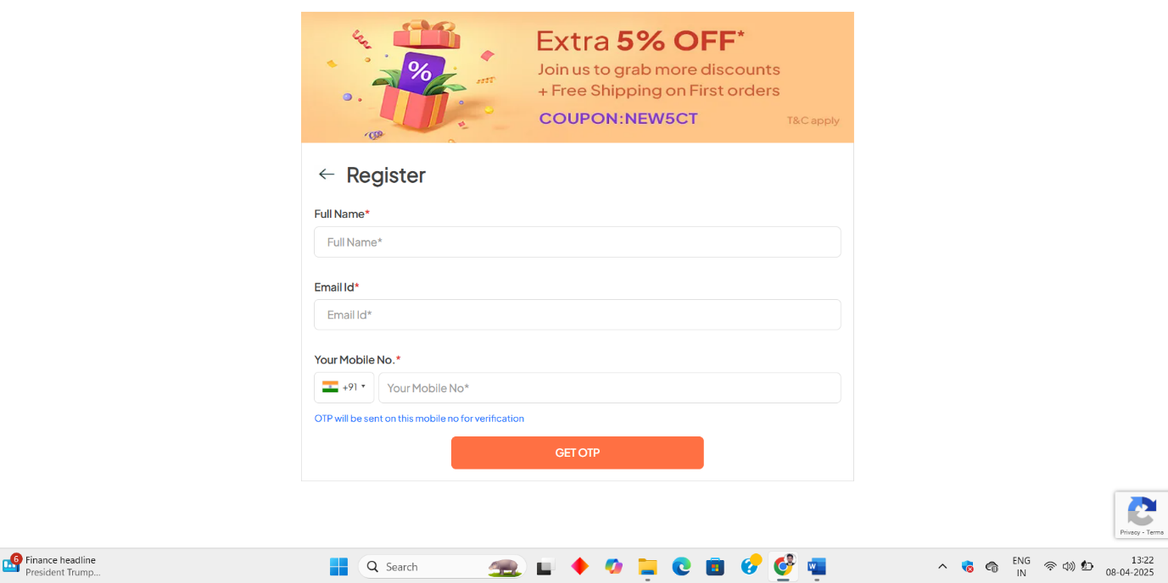

To reach this site customer should type [www.toyshop.com](http://www.toyshop.com) on web browser he will see the web application. Then he should fill the necessary details and get registered.

**Log in:**

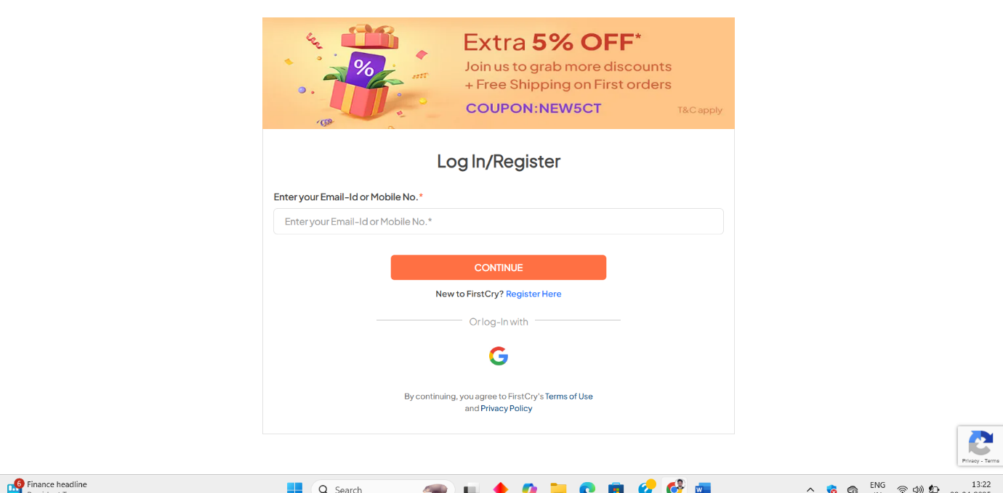

After registration user will see the log in page. He should type the correct user ID and password at right place and log in to the system. Then he will see the home page.

**\**

**Home page:**

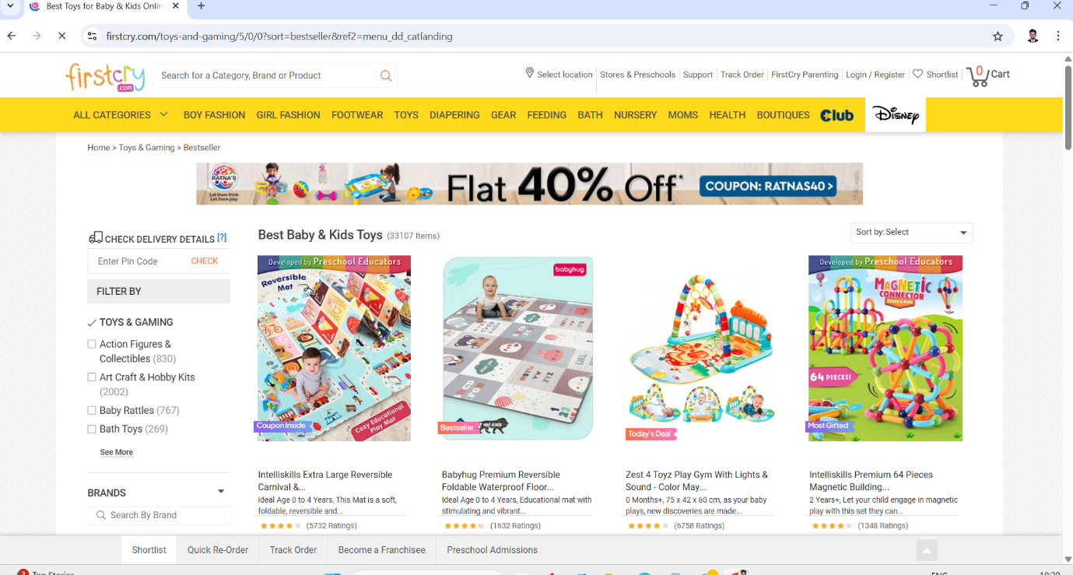

After login, the Home page will be visible to the user. On that page, users can search for the products. There is the option of a sort dropdown button on which you can sort the product according to the age of the kid, price of product, brand of product, etc.

**Add to cart page:**

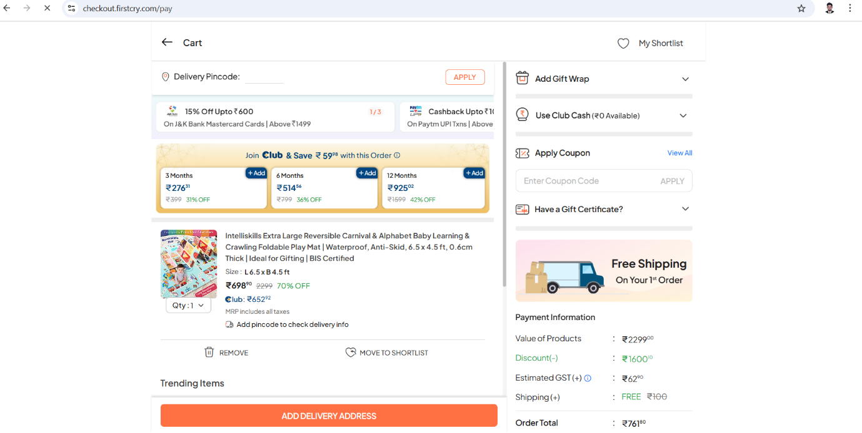

After the home page, the above screen is visible. On clicking that image you can see the description of the product.

|  |  |
| --- | --- |
| **Features** | **Functionality** |
| Buy now | This button directly navigates to address and payment page. |
| Cart | This button adds the product in to the cart. |
| Search | In this text box you can search the product. |
| Sort | This button is can sort the products according various criteria. |

In this page, user can see the products which were added in the cart and they can proceed to address and payment.

**Payment page:**

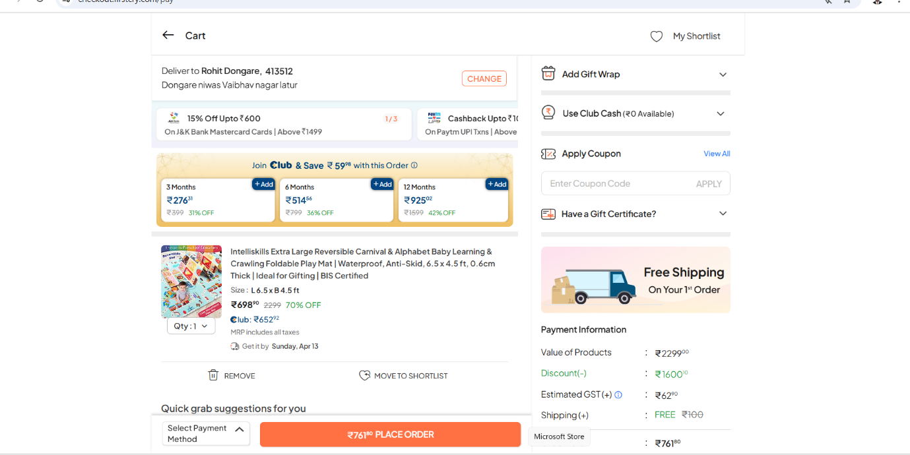

After adding address, user will see payment screen then he can pay the money and confirm the order.

|  |  |
| --- | --- |
| **Feature** | **Functionality** |
| Card payment | User can pay the money from card. |
| Net banking | User can pay the money by net banking. |
| Cash | User can pay the money by cash on delivery. |

# 5. Project estimation portal:

**Admin portal:**

|  |  |  |  |
| --- | --- | --- | --- |
| **Module** | **Features** | **Back-end hours** | **Front end hours** |
| Basic setup | 1. Configuring AWS  2. environ Design database schemes  3. Code repository setup | 10 | 0 |
| Account | 1. Database table design  2. Admin login  3. Forgot password  4. Update data | 5 | 10 |
| Settings | 1. Add, view and edit manager and receptionist login IDs  2. Add. Update, delete toy availability, amenities, etc. | 5 | 5 |
| Customer Details | 1. Search customer details  2. Add, view customer information  3. View customer booking details | 5 | 5 |

**Content manager portal:**

|  |  |  |  |
| --- | --- | --- | --- |
| **Module** | **Features** | **Back-end hours** | **Front end hours** |
| Account | 1. Data table design  2. Forgot password  3. Update data | 5 | 10 |
| Settings | 1. Add, update and delete product availability.  2. Create offers and discounts.  3. View staff attendance | 5 | 5 |
| Customer details | 1. Search for customer details. 2. Add, view customer information. 3. View customer booking details. 4. Check in and check out. | 5 | 5 |
| Reports | 1. Revenue reports | 5 | 5 |

**Customer support portal:**

|  |  |  |  |
| --- | --- | --- | --- |
| **Module** | **Features** | **Back-end hours** | **Front end hours** |
| Account | 1.Read/Resolve Customer query  2. Respond through mail  3. Update data | 5 | 10 |
| Settings | 1. Create FAQ’s.  2. Respond through mail.  3.On/Off AI chatbot. | 5 | 5 |
| Customer details | 1. Search for customer details 2. Add, view customer information 3. View customer booking details 4. Check-in and check-out 5. Assign keys | 5 | 5 |
| Reports | 1. Check the query resolution report | 2 | 2 |

**Customer portal:**

|  |  |  |  |
| --- | --- | --- | --- |
| **Module** | **Features** | **Back-end hours** | **Front end hours** |
| Account | 1. Database table design  2. Register customer  3. Enter customer details  4. Login  5. Forgot password | 5 | 10 |
| Booking | 1.Product availability  2. Enter customer details  3. Accept terms and conditions of shop  4. Book the rooms and packages  5. Cancel the bookings | 5 | 5 |
| Payments | 1. Review booking 2. Make the payments 3. Check the bill for the booking 4. Check booking confirmation 5. Track the refund after cancellation | 5 | 5 |
| Feedback | 1. Give feedback on the services  2. Raise complaints and track status | 2 | 2 |

|  |  |  |  |  |
| --- | --- | --- | --- | --- |
| **No. of Resources** | **Type of Resources** | **No. of days** | **No. of hours/day** | **Total hours** |
| 1 | Backend Developer | 12 | 9 | 108 |
| 1 | Frontend Developer | 12 | 9 | 108 |
| 1 | Database Developer | 5 | 9 | 45 |
| 1 | Tester | 10 | 9 | 90 |
| 1 | Business Analyst | 30 | 9 | 270 |
| 1 | Project Manager | 30 | 3 | 90 |
| 1 | Executive (Support) | 15 | 2 | 30 |

# Project team:

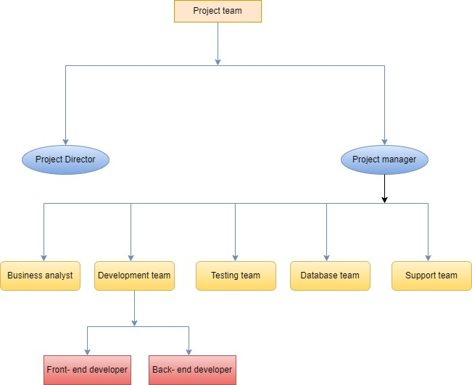

The project team for developing a toy shop application consists of key roles ensuring a smooth transition from manual operations to a digital platform. The Business Analyst (BA) gathers requirements from stakeholders and ensures the application meets business needs. The Project Manager oversees timelines, resources, and risks. The UI/UX Designer creates an intuitive interface for a seamless shopping experience. The Developers (Frontend & Backend) build the application, integrating product catalogues, payment gateways, and order tracking features. The QA Testers ensure functionality and performance meet standards before launch. Finally, the Support & Maintenance Team handles post-launch updates and issue resolution. Effective collaboration among these roles provides a successful digital transformation for the toy shop.

# Business requirement document (BRD):

**Project name:** Toy shop web application

|  |  |  |  |  |  |
| --- | --- | --- | --- | --- | --- |
| **Version** | **Prepared by** | **Prepared date** | **Review by** | **Review date** | **Change log** |
| V1.0 | Rohit Dongare | 15/03/2025 | Mr. Omkar Pathak sir | 20/03/2025 | NA |
|  |  |  |  |  |  |
|  |  |  |  |  |  |

**1. Problem statement:**

**1.1 Less Customer Reach:**

Shop is located in particular area so the customer is not aware of that shop as well as every time they have to come in shop to buy toys so it is not possible to reach every customer in less time.

**1.2 Maintain data Manually:**

Client’s as is working procedure is manual to maintain the records. It is time-consuming and difficult to use the data.

**1.3 Human Errors:**

Because of complex business process, it is very difficult to update everything every time so there is difficult to tracking every single modification, payment information and refund information.

**1.4 Refund process:**

Refund procedure is also hectic as well as time-consuming.

**1.5 Complicated cancellation process:**

If you want to cancel your purchased toy in an emergency or any situation so you have to visit shop for cancelling your toy as well the full booking procedure is cancelled from scratch and it is really difficult to maintain this type of data.

**1.6 Time consuming process:**

Because of maintaining all data manually and maintain hard copies it is really time consuming.

**2.** **Project scope: (Goal of the project)**

The application will cater to customers looking to buy toys online and toy shop owners managing their stores. The system will include user registration, a product catalogue, a shopping cart, a payment gateway, order tracking, and customer support functionalities.

|  |  |  |  |  |  |  |
| --- | --- | --- | --- | --- | --- | --- |
| **Product Features of Customer** | | | | | | |
| **Category** | **Section** | | | **Actions** | | **Sub-Actions** |
| **Authentication** | Login | | | Login | | Enter credentials (email/username, password) & Authenticate. |
| **Purchase** | Purchase the product | | | Buy now | | pay the money and add address |
| **Registration** | Register | | | Register | | Submit registration details. |
| **Refund** | Demand for refund | | | Demand for refund | | Enter refund reason |
| **Profile** | Edit Profile | | | Edit Profile | | Change the necessary details and submit |
| **Order** | Create/Update/Delete Booking | | | Create/Update/Delete Booking | | Edit the booking entter necessary details. |
| **Payment** | Create/Update Payement | | | Create/Update Payement | | Enter payment method and proceed. |
| **Log out** | Log out | | | Log out | | Press the log out button and confirm. |
| **Cart** | Add product to cart | | | Add product to cart | | Add n number of products at same time and purchase it. |
| **View** | View products | | | View products | | Home page you can view the products. |
| **Feedback** | Feedback | | | Feedback | | Add feedback to textbox and submit. |
| **Contact** | Contact delivery boy by call | | | Contact delivery boy by call | | You can chat with customer support. |
| **Cancellation** | Cancel Order | | | Cancel Order | | Enter the reason for cancellation and cancel the order. |
|  |  | | |  | |  |
| **Product Features of Admin** | | | | | | |
| **Category** | | **Section** | **Actions** | | **Sub-Actions** | |
| **Authentication** | | Login | Login | | Enter credentials (email/username, password) & Authenticate. | |
| **Transactions** | | Track transactions | Transactions | | Click on view transactions. | |
| **Registration** | | Register | Register | | Submit registration details. | |
| **Provide promocode** | | Provide promocode | Go on promocode option | | Enter credentials. | |
| **Profile** | | Edit Profile | Edit Profile | | Change the necessary details and submit | |
| **Holiday** | | Create/Update/Delete Holiday | Create/Update/Delete Booking | | Edit the holiday entter necessary details. | |
| **Payment** | | Create/Update Payement | Create/Update Payement | | Enter payment method and proceed. | |
| **Logout** | | Log out | Log out | | Press the log out button and confirm. | |
| **Roles** | | Create roles | Click on roles. | | Enter necessary details. | |
| **Product Features of Admin** | | View products | View products | | Home page you can view the products. | |
| **Feedback** | | Feedback | Feedback | | Add feedback to textbox and submit. | |
| **Purchase rate** | | User purchase rate | User purchase rate | |  | |
| **Refund** | | Update refund | Click on refund | | Enter reason for refund and refund amount. | |

|  |  |  |  |
| --- | --- | --- | --- |
| **Product Features of Customer support** | | | |
| **Category** | **Section** | **Actions** | **Sub-Actions** |
| **Authentication** | Login | Login | Enter credentials (email/username, password) & Authenticate. |
| **Read booking** | Bookings | Bookings | Read booking details |
| **Registration** | Register | Register | Submit registration details. |
| **Chat option** | Chat | Chat | Chat with customer |
| **Profile** | Edit Profile | Edit Profile | Change the necessary details and submit |
| **Mail** | Email | Email | Send mail |
| **Feedback** | Read feedback | Read feedback | Read feedback and respond. |
| **Log out** | Log out | Log out | Press the log out button and confirm. |
| **Alert** | Maintainance | Maintainance | Click on create alert. |
| **View** | View products | View products | Home page you can view the products. |

|  |  |  |  |
| --- | --- | --- | --- |
| **Product Features of Inventory support** | | | |
| **Category** | **Section** | **Actions** | **Sub-Actions** |
| **Authentication** | Login | Login | Enter credentials (email/username, password) & Authenticate. |
| **Products** | Track Number of products | Track Number of products | Click on Product details |
| **Registrations** | Register | Register | Submit registration details. |
| **Order products** | Order products | Order products | Click on order. |
| **Profile** | Edit Profile | Edit Profile | Change the necessary details and submit |
| **Holiday** | Create/Update/Delete Holiday | Create/Update/Delete Booking | Edit the holiday entter necessary details. |
| **Payment** | Create/Update Payement | Create/Update Payement | Enter payment method and proceed. |
| **Logout** | Log out | Log out | Press the log out button and confirm. |
| **Roles** | Create roles | Click on roles. | Enter necessary details. |
| **Product Features of Admin** | View products | View products | Home page you can view the products. |

|  |  |  |  |
| --- | --- | --- | --- |
| **Product Features of accounts** | | | |
| **Category** | **Section** | **Actions** | **Sub-Actions** |
| **Authentication** | Login | Login | Enter credentials (email/username, password) & Authenticate. |
| **Products** | Track Number of products | Track Number of products | Click on Product details |
| **Registrations** | Register | Register | Submit registration details. |
| **Creating Budget report** | Creating Budget report | Creating Budget report | Click on budget report. |
| **Analysing Final accounts** | Analysing Final accounts | Analysing Final accounts | Click on final accounts |
| **Providing receipt** | Providing receipt | Providing receipt | Edit the holiday entter necessary details. |
| **Paying salary** | Paying salary | Paying salary | Enter payment method and proceed. |
| **Payment history** | Payment history | Payment history | Press the log out button and confirm. |

**3. As is business process:**

**a. UML diagram on high level:**

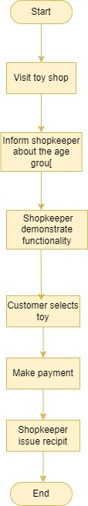

**Activity diagram:**

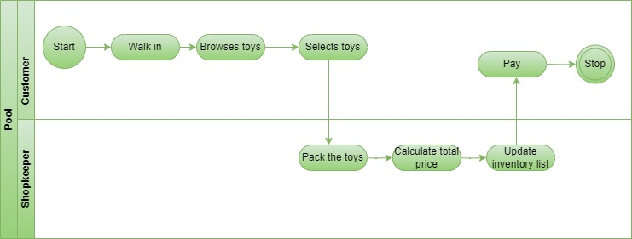

**As is the business process description:**

The As-Is Business Process for the toy shop follows a manual workflow, where customers visit the store, browse products, seek assistance if needed, and make purchases at a physical counter. Inventory and sales records are updated manually, and payment is processed in cash or online. This process is labour-intensive and prone to inefficiencies, such as stock mismanagement and customer wait times.

**2. To be business process:**

**High-level UML diagram:**

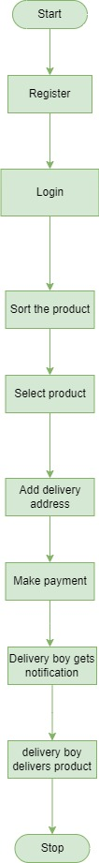

**Activity diagram:**

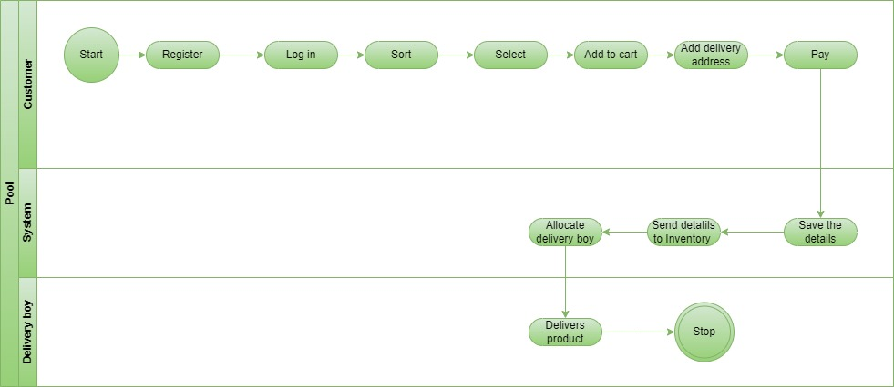

The Toy Shop Application allows customers to browse toys by category, search with filters, and add items to their cart. Users register and log in to place orders, enter shipping details, and make payments via multiple options. Once an order is confirmed, inventory is updated, and admins process packaging and dispatch. Customers receive tracking updates until delivery. They can contact customer support for issues, request refunds, or leave reviews. Admins manage inventory, analyze sales trends, and monitor customer behaviour through a dashboard. The system ensures a seamless shopping experience from product discovery to delivery and feedback.

**UI screens:**

**Screen 1: Registration page**

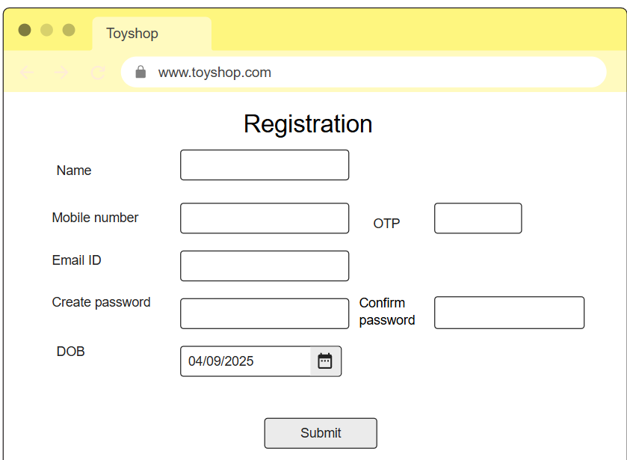

* 1. **UI Screen for registration:**
* First & Last Names should be max 30 character. [Mandatory field].
* Enter Email ID & Mobile number. [Mandatory field].
* Enter OTP for mobile number and email respectively. [Mandatory field].
* Create a password containing at least one number and alphabets and repeat it. [Mandatory field].
* Enter DOB and create the account. [Mandatory field].

**Screen 2: Log in page**

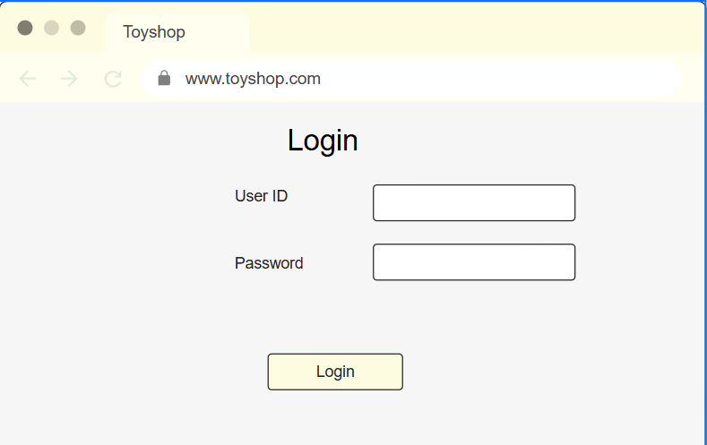

* 1. **UI screen for log in page:**
* User ID should be 8 to 15 letters [no special character/symbol].
* Create a password containing at least one number and alphabets and repeat it. [Mandatory field].
* Below user ID/Pass registration for new user.
* If user forgets his login id or password he can click on Forgot Password.

**Screen 3: Home page**

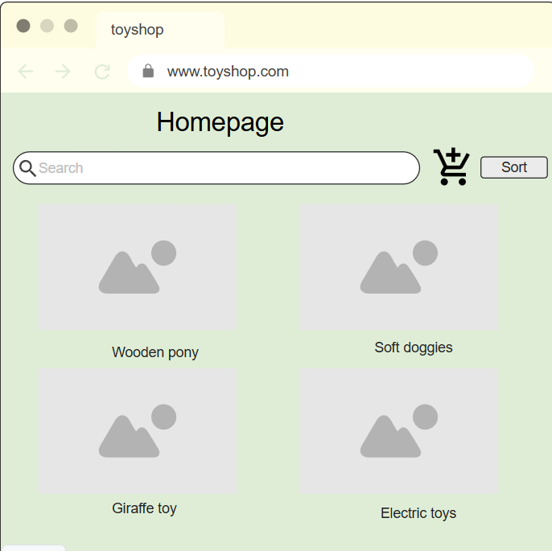

* 1. **UI screens for home page:**
* In this page customer can sort the toys according to age group or their choice of toy they want

**Screen 4: Add to cart**

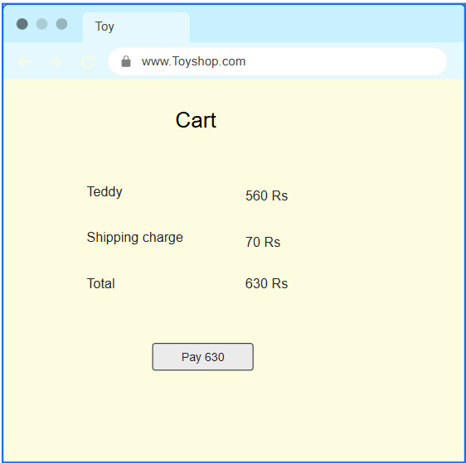

In this page user can see total price of items and proceed to payment.

**Screen 5: Payment page**

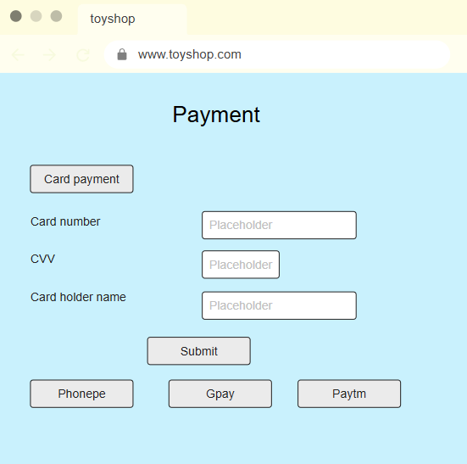

* 1. **UI Screens for payment methods:**
* In Select payment method where customer will choose a type by swipe [Debit/Credit].
* VISA, MASTER and Rub Pay card customer has to choose one.
* Net Banking can choose from drop down list there is a drop-down list.
* Cash on Delivery selecting customer has to do pay cash.
  1. **UI screens for pay receipt:**
* After doing the payment user can see payments payment successful message (in case of successful transaction) & can generate receipt.

1. **Non-functional requirements:**
   1. **UI requirements:**

* User Interface requirement is simple and easy appearance
* Colour of text, foreground and background will be contrast.
  1. **Software requirement:**
* Any operating system can be used with help of internet browser.
  1. **Hardware Requirement**
* Processor minimum i5 and HDD 250 GB/RAM minimum 8 GB.

1. **Assumptions and constraints:**

**1) Assumptions:**

* 1. Toy shop application will be entirely managed by the administration.
  2. End users should be of 18+ age.
  3. Every user has an account created and authenticated by the administration.
  4. Unless the payment phase is completed, the system will not allow the booking capabilities.
  5. Toy shop application will work on a server that needs to be always online.

**2) Constraints:**

1. Response time for loading the product should take no longer than five minutes.
2. Application size is 50 MB maximum.
3. All import data will be available in PDF, doc format.
4. Application language only in English.
5. Default currency type will be Indian rupees.

# Software requirement specifications:

|  |  |  |  |  |  |
| --- | --- | --- | --- | --- | --- |
| **Version** | **Prepared by** | **Prepared date** | **Review by** | **Review date** | **Change log** |
| V1.0 | Rohit Dongare | 15/03/2025 | Mr. Omkar Pathak sir | 20/03/2025 | NA |
|  |  |  |  |  |  |
|  |  |  |  |  |  |

**1. Problem Statement:**

**1.1 Less Customer Reach:**

Shop is located in particular area so the customer is not aware of that shop as well as every time they have to come in shop to buy toys so it is not possible to reach every customer in less time.

**1.2 Maintain data Manually:**

Client’s as is working procedure is manual to maintain the records. It is time-consuming and difficult to use the data.

**1.3 Human Errors:**

Because of complex business process, it is very difficult to update everything every time so there is difficult to tracking every single modification, payment information and refund information.

**1.4 Refund process:**

Refund procedure is also hectic as well as time-consuming.

**1.5 Complicated cancellation process:**

If you want to cancel your purchased toy in an emergency or any situation so you have to visit shop for cancelling your toy as well the full booking procedure is cancelled from scratch and it is really difficult to maintain this type of data.

**1.6 Time consuming process:**

Because of maintaining all data manually and maintain hard copies it is really time consuming.

**2.** **Project scope: (Goal of the project)**

The application will cater to customers looking to buy toys online and toy shop owners managing their stores. The system will include user registration, a product catalog, shopping cart, payment gateway, order tracking, and customer support functionalities.

|  |  |  |  |  |  |  |
| --- | --- | --- | --- | --- | --- | --- |
| **Product Features of Customer** | | | | | | |
| **Category** | **Section** | | | **Actions** | | **Sub-Actions** |
| **Authentication** | Login | | | Login | | Enter credentials (email/username, password) & Authenticate. |
| **Purchase** | Purchase the product | | | Buy now | | pay the money and add address |
| **Registration** | Register | | | Register | | Submit registration details. |
| **Refund** | Demand for refund | | | Demand for refund | | Enter refund reason |
| **Profile** | Edit Profile | | | Edit Profile | | Change the necessary details and submit |
| **Order** | Create/Update/Delete Booking | | | Create/Update/Delete Booking | | Edit the booking entter necessary details. |
| **Payment** | Create/Update Payement | | | Create/Update Payement | | Enter payment method and proceed. |
| **Log out** | Log out | | | Log out | | Press the log out button and confirm. |
| **Cart** | Add product to cart | | | Add product to cart | | Add n number of products at same time and purchase it. |
| **View** | View products | | | View products | | Home page you can view the products. |
| **Feedback** | Feedback | | | Feedback | | Add feedback to textbox and submit. |
| **Contact** | Contact delivery boy by call | | | Contact delivery boy by call | | You can chat with customer support. |
| **Cancellation** | Cancel Order | | | Cancel Order | | Enter the reason for cancellation and cancel the order. |
|  |  | | |  | |  |
| **Product Features of Admin** | | | | | | |
| **Category** | | **Section** | **Actions** | | **Sub-Actions** | |
| **Authentication** | | Login | Login | | Enter credentials (email/username, password) & Authenticate. | |
| **Transactions** | | Track transactions | Transactions | | Click on view transactions. | |
| **Registration** | | Register | Register | | Submit registration details. | |
| **Provide promocode** | | Provide promocode | Go on promocode option | | Enter credentials. | |
| **Profile** | | Edit Profile | Edit Profile | | Change the necessary details and submit | |
| **Holiday** | | Create/Update/Delete Holiday | Create/Update/Delete Booking | | Edit the holiday entter necessary details. | |
| **Payment** | | Create/Update Payement | Create/Update Payement | | Enter payment method and proceed. | |
| **Logout** | | Log out | Log out | | Press the log out button and confirm. | |
| **Roles** | | Create roles | Click on roles. | | Enter necessary details. | |
| **Product Features of Admin** | | View products | View products | | Home page you can view the products. | |
| **Feedback** | | Feedback | Feedback | | Add feedback to textbox and submit. | |
| **Purchase rate** | | User purchase rate | User purchase rate | |  | |
| **Refund** | | Update refund | Click on refund | | Enter reason for refund and refund amount. | |

|  |  |  |  |
| --- | --- | --- | --- |
| **Product Features of Customer support** | | | |
| **Category** | **Section** | **Actions** | **Sub-Actions** |
| **Authentication** | Login | Login | Enter credentials (email/username, password) & Authenticate. |
| **Read booking** | Bookings | Bookings | Read booking details |
| **Registration** | Register | Register | Submit registration details. |
| **Chat option** | Chat | Chat | Chat with customer |
| **Profile** | Edit Profile | Edit Profile | Change the necessary details and submit |
| **Mail** | Email | Email | Send mail |
| **Feedback** | Read feedback | Read feedback | Read feedback and respond. |
| **Log out** | Log out | Log out | Press the log out button and confirm. |
| **Alert** | Maintainance | Maintainance | Click on create alert. |
| **View** | View products | View products | Home page you can view the products. |

|  |  |  |  |
| --- | --- | --- | --- |
| **Product Features of Inventory support** | | | |
| **Category** | **Section** | **Actions** | **Sub-Actions** |
| **Authentication** | Login | Login | Enter credentials (email/username, password) & Authenticate. |
| **Products** | Track Number of products | Track Number of products | Click on Product details |
| **Registrations** | Register | Register | Submit registration details. |
| **Order products** | Order products | Order products | Click on order. |
| **Profile** | Edit Profile | Edit Profile | Change the necessary details and submit |
| **Holiday** | Create/Update/Delete Holiday | Create/Update/Delete Booking | Edit the holiday entter necessary details. |
| **Payment** | Create/Update Payement | Create/Update Payement | Enter payment method and proceed. |
| **Logout** | Log out | Log out | Press the log out button and confirm. |
| **Roles** | Create roles | Click on roles. | Enter necessary details. |
| **Product Features of Admin** | View products | View products | Home page you can view the products. |

|  |  |  |  |
| --- | --- | --- | --- |
| **Product Features of accounts** | | | |
| **Category** | **Section** | **Actions** | **Sub-Actions** |
| **Authentication** | Login | Login | Enter credentials (email/username, password) & Authenticate. |
| **Products** | Track Number of products | Track Number of products | Click on Product details |
| **Registrations** | Register | Register | Submit registration details. |
| **Creating Budget report** | Creating Budget report | Creating Budget report | Click on budget report. |
| **Analysing Final accounts** | Analysing Final accounts | Analysing Final accounts | Click on final accounts |
| **Providing receipt** | Providing receipt | Providing receipt | Edit the holiday entter necessary details. |
| **Paying salary** | Paying salary | Paying salary | Enter payment method and proceed. |
| **Payment history** | Payment history | Payment history | Press the log out button and confirm. |

**As is the business process: (Low level)**

1. The As-Is Business Process for the toy shop follows a manual workflow. customers visit the store.
2. He tells the shopkeeper which age group he wants to buy the toys.
3. According to that, the shopkeeper suggests the toys and shows him how that toy works.
4. After that customer selects the toy to purchase and makes payment online or cash.
5. The shopkeeper gives him a receipt for it and update in inventory list.

**As is business process low level flow chart**

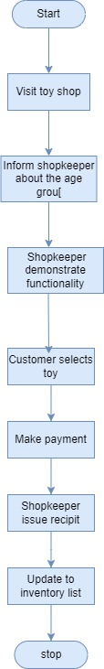

**Low level activity diagram:**

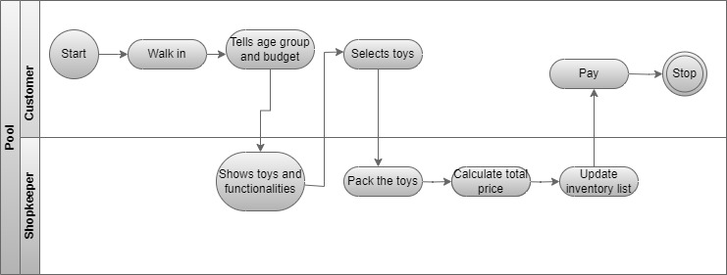

**To be flow chart:**

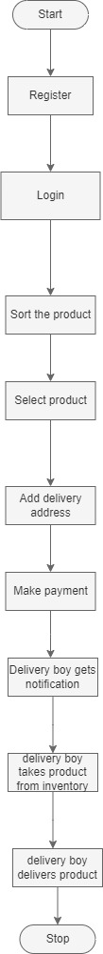

**To be low level Activity diagram:**

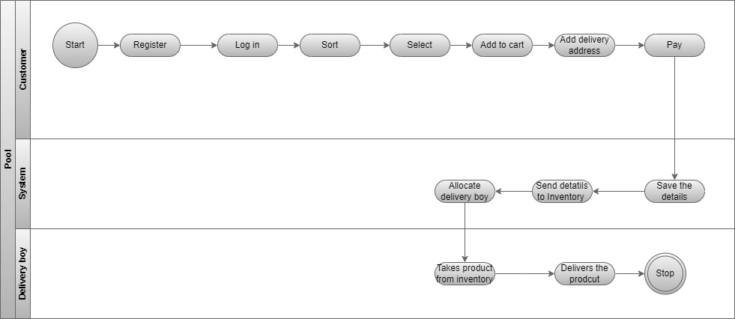

**To be business process low level:**

1. The process of buying a toy from the shop begins with the customer browsing through various toy categories, using filters like age group, price, and brand to find the perfect item.
2. Once they select a toy, they can either add it to their shopping cart for immediate purchase or save it to a Wishlist for later. At checkout, the customer reviews their cart, adjusts quantities if needed, and proceeds to enter their shipping details.
3. They choose a delivery option, such as standard or express shipping, and select a payment method, including credit/debit cards, digital wallets, UPI, or cash on delivery. After confirming the order, the system processes the payment securely and sends an order confirmation via email or SMS.
4. Simultaneously, the shop updates its inventory, notifies the admin, and initiates packaging. The order is then dispatched through a courier service, and the customer receives tracking details to monitor the shipment.
5. Once delivered, the system updates the order status, and the customer is encouraged to leave feedback or a review.
6. If they encounter any issues, they can request a return, exchange, or contact customer support for assistance. This seamless workflow ensures a smooth and efficient shopping experience from selection to delivery.

**Functional specifications:**

**Use case diagrams:**

**Customer:**

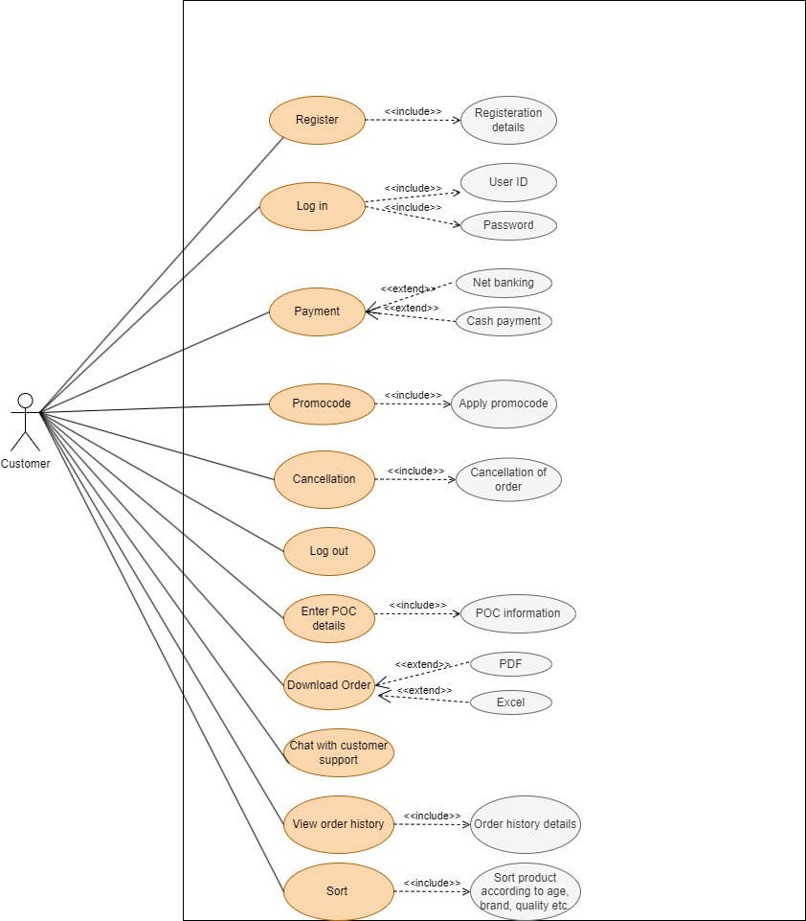

**Admin:**

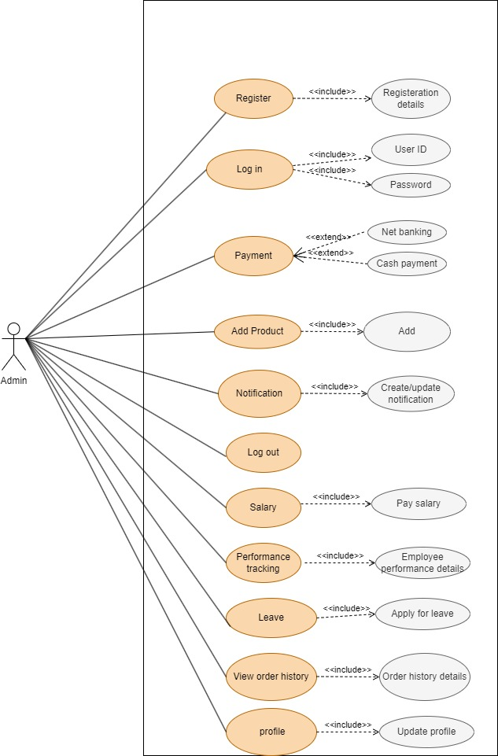

**Content manager:**

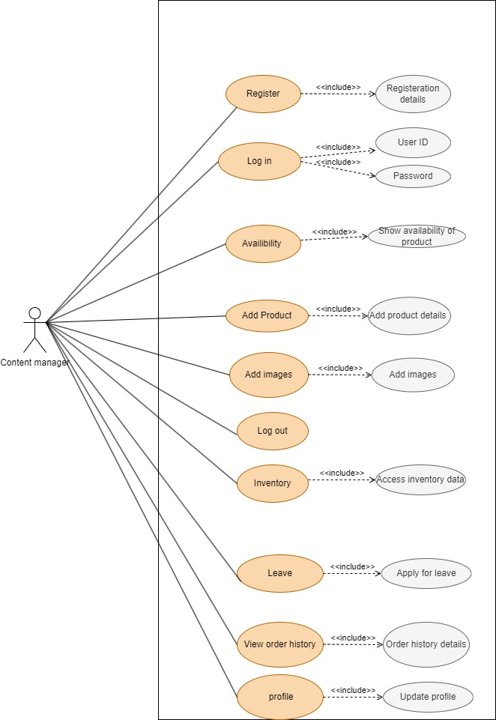

**Inventory manager:**

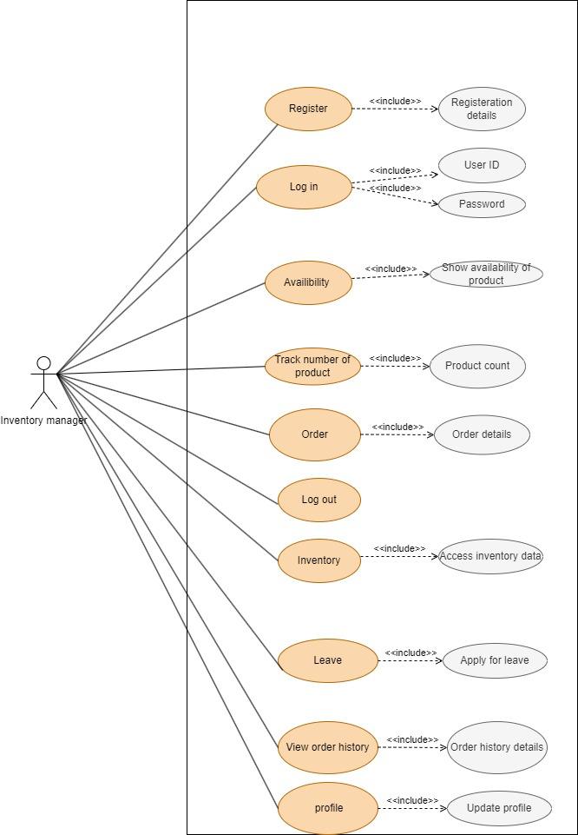

**Accounts:**

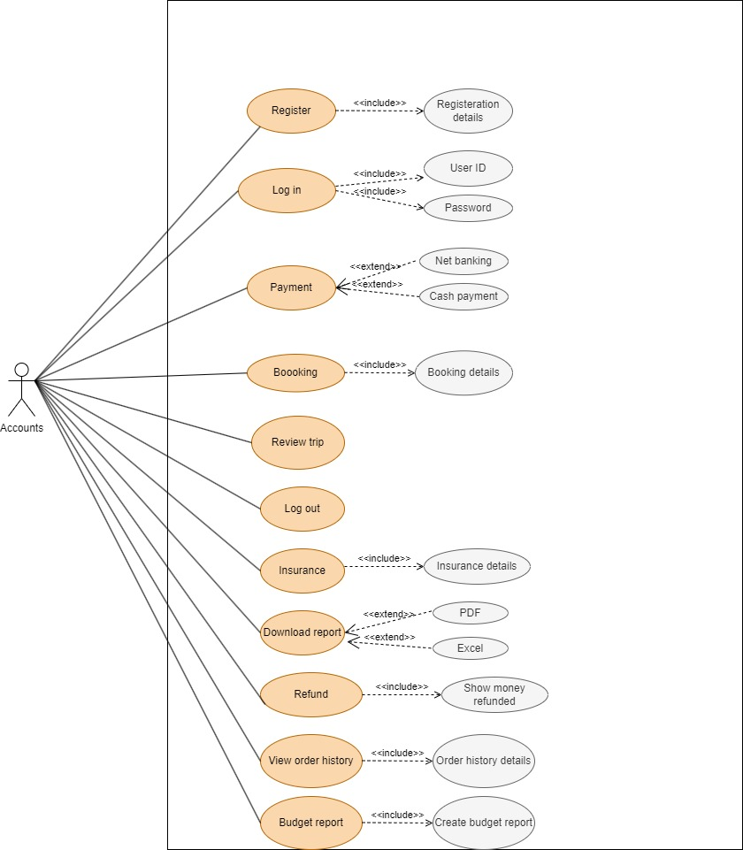

**Data flow diagram:**

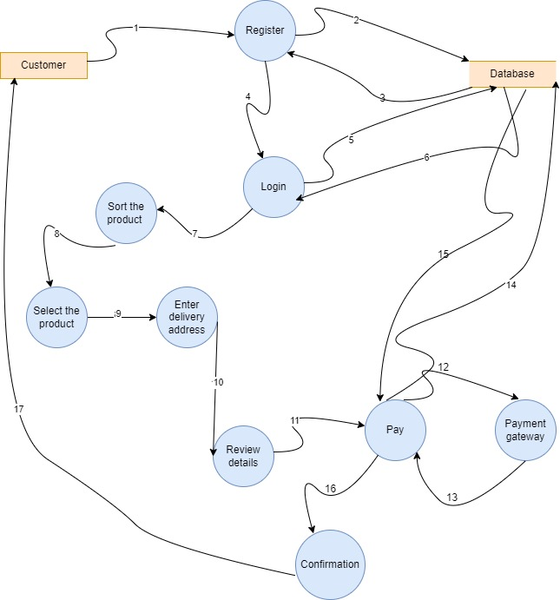

The Data Flow Diagram (DFD) illustrates the process of purchasing a toy from an online application. The customer selects a toy, adds it to the cart, and proceeds to checkout. The application checks stock availability with the Inventory System and confirms it before processing the payment through the Payment Gateway. Upon successful payment, the order details are saved in the Order Database, and stock updates are made in the Inventory Database. The application then requests shipping from the Shipping Provider, which updates the Shipping Database and provides tracking details. Finally, the customer receives an order confirmation along with tracking information.

**Sequence diagram:**

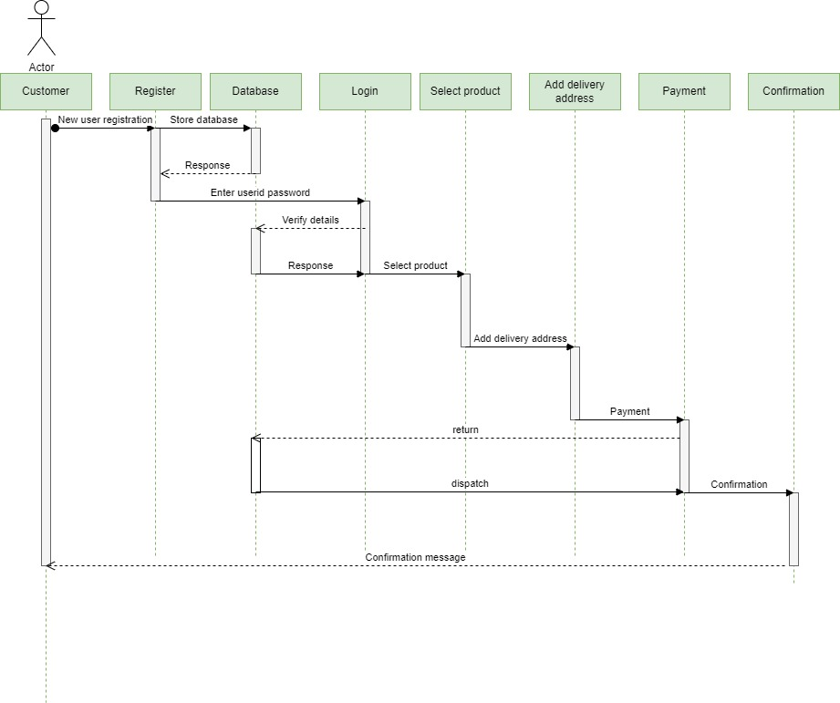

The sequence diagram illustrates the process of a customer purchasing a toy from an online application. The interaction begins when the customer browses and selects a toy, adds it to the cart, and proceeds to checkout. The application then checks stock availability with the inventory system. If stock is confirmed, the customer initiates payment, which is processed through the payment gateway. Upon successful payment, the application confirms the order, updates the inventory, and requests shipping from the shipping provider. Once the shipping provider dispatches the order, the application updates the customer with tracking details, completing the purchase process.

**Use case specifications:**

**Registration:**

|  |  |  |  |  |  |  |  |  |  |  |  |
| --- | --- | --- | --- | --- | --- | --- | --- | --- | --- | --- | --- |
| Use Case ID: | | | | | Ucid001 | Prepared By | | | Rohit Dongare | | |
|  | | | | | | Prepared Date | | | --/--/---- | | |
| Use Case Name: New user can register. | | | | | | | | | | | |
| Use case Diagram: | | | | | | | | | | | |
| **Actors:** New user | | | | | | | | | | | |
| **Pre -Condition** | | | | | | | | | | | |
| 1. User must be 18+ | | | | | | | | | | | |
| **Successful Post Condition** | | | | | | **Unsuccessful Post Condition** | | | | | |
| 1. Show pop-up window with message ‘user registration is successful’ 2. Click on ok button navigate to login page. | | | | | | 1. User stay on registration page 2. Show validation message below field name in color red font arial size 10. 3. Please refer validation message in field validation table. | | | | | |
| **Basic Flow** | | | | | | **Alternate flow** | | | | | |
| 1. Click on register link in top right corner of home page. 2. User enters mandatory fields. 3. Click on ‘submit’ button | | | | | | 1. Click on register link on footer and pre payment page. 2. Fill mandatory fields. 3. Click on submit button. | | | | | |
| **Field Validation Table** | | | | | | | | | | | |
| Sr. No | Field Name | Control type | Data type | Length | Default Value | Other Value | Functional Requirement | Business Rule | | Validation Role | Validation Message |
| 1 | Name | Text Box | Character | 50 | Please Enter your name | NA | Please Enter Username | NA | | 1.Mandatory | For validation Rule 1 show below message. ‘Please enter name’ |
| 2.No Space Before/After/ in between | For validation Rule 2 show below message. ‘Please enter name without  space’ |
| 3.Character only | For validation Rule 3 show below message. ‘Please enter character  only’ |
| 2 | Mobile | Text Box | Numeric | 10 | Please Enter mobile numner | NA | Please Enter mobile numner | NA | | 1.Mandatory | For validation Rule 1 show below message. ‘Please enter  OTP |
| 2.No Space Before/After/ in-between | For validation Rule 2 show below message. ‘Please enter OTP  without space’ |
| 3.Numeric only | For validation Rule 3 show below message. ‘Please enter  Numeric value only’ |
| 3 | OTP | Text Box | Numeric | 6 | Please Enter OTP | NA | Please Enter OTP | NA | | 1.Mandatory | For validation Rule 1 show below message. ‘Please enter  OTP |
| 2.No Space Before/After/ in-between | For validation Rule 2 show below message. ‘Please enter OTP  without space’ |
| 3.Numeric only | For validation Rule 3 show below message. ‘Please enter  Numeric value only’ |
| 4 | Password | Text Box | Alphanumeric | 8 | Please Enter Password | NA | Please Enter Password | NA | | 1.Mandatory | For validation Rule 1 show below message. ‘Please enter  Password’ |
| 2.No Space Before/After/ in-between | For validation Rule 2 show below message. ‘Please enter Password  without space’ |
| 3.Alphanumer ic only | For validation Rule 3 show below message. ‘Please enter  Alphanumeric only’ |
| 5 | Address | Text Box | Alphanumeric | 150 | Please enter address | NA | Please enter address | NA | | 1.Mandatory | For validation Rule 1 show below message. ‘Please enter  Address’ |
| 2.Space Before/After/ in-between | For validation Rule 2 show below message. ‘Please enter address  without space’ |
| 3.Alphanumer ic only | For validation Rule 3 show below message. ‘Please enter  Alphanumeric only’ |
| 6 | Submit button | Button | _- | _- | - | _- | - | _- | | 1. Mandatory | For validation, Rule 1 shows the below message. ‘Add to cart the product to purchase it,’  .’ |
| 2.No Space Before/After/ in-between | For validation Rule 2 show below message. ‘Please enter Password  without space’ |
| 3.Alphanumer ic only | For validation Rule 3 show below message. ‘Please enter  Alphanumeric only’ |

* 1. Use Case Specification (User Login)

|  |  |  |  |  |  |  |  |  |  |  |  |
| --- | --- | --- | --- | --- | --- | --- | --- | --- | --- | --- | --- |
| Use Case ID: | | | | | Ucid01 | Prepared By | | | Rohit Dongare | | |
|  | | | | | | Prepared Date | | | --/--/---- | | |
| Use Case Name: Existing User can Login | | | | | | | | | | | |
| Use case Diagram: | | | | | | | | | | | |
| Actors: Existing User | | | | | | | | | | | |
| **Pre -Condition** | | | | | | | | | | | |
| 1. User must have valid username & password | | | | | | | | | | | |
| **Successful Post Condition** | | | | | | **Unsuccessful Post Condition** | | | | | |
| 1. User must be logged into the system 2. User must navigate to car booking page | | | | | | 1. User stay on Login page 2. User enters the wrong username & password 3. Validation message is shown to user below field name in color ‘Red’ font ‘Arial’ size 10 4. 4. Refer validation message in validation table | | | | | |
| **Basic Flow** | | | | | | **Alternate flow** | | | | | |
| 1. System displays a Login page 2. User enters a correct username & password 3. Click on ‘Login’ button | | | | | | Not Applicable | | | | | |
| **Field Validation Table** | | | | | | | | | | | |
| Sr. No | Field Name | Control type | Data type | Length | Default Value | Other Value | Functional Requirement | Business Rule | | Validation Role | Validation Message |
| 1 | Username | Text Box | Character | 10-50 | Please Enter User name | NA | Please Enter Username | NA | | 1.Mandatory | For validation Rule 1 show below message. ‘Please enter  Username’ |
| 2.No Space Before/After/ inbetween | For validation Rule 2 show below message. ‘Please enter Username without  space’ |
| 3.Character only | For validation Rule 3 show below message. ‘Please enter character  only’ |
| 2 | Password | Text Box | Alphanumeric | 8 | Please Enter Password | NA | Please Enter Password | NA | | 1.Mandatory | For validation Rule 1 show below message. ‘Please enter  Password’ |
| 2.No Space Before/After/ in-between | For validation Rule 2 show below message. ‘Please enter Password  without space’ |
| 3.Alphanumer ic only | For validation Rule 3 show below message. ‘Please enter  Alphanumeric only’ |

**Use case specifications to add to cart the product**

|  |  |  |  |  |  |  |  |  |  |  |  |  |  |
| --- | --- | --- | --- | --- | --- | --- | --- | --- | --- | --- | --- | --- | --- |
| **Use Case ID:** | | | Ucid035 | | | | **Prepared By** | | | | Rohit Dongare | | |
|  | | | | | | | **Prepared Date** | | | | --/--/---- | | |
| **Use Case Name:** Sort the product and add to cart. | | | | | | | | | | | | | |
| **Use case diagram:** | | | | | | | | | | | | | |
| **Actors:** Existing Customer | | | | | | | | | | | | | |
| **Pre -Condition** | | | | | | | | | | | | | |
| 1. The user must be login to the system. | | | | | | | | | | | | | |
| **Successful Post Condition** | | | | | | | **Unsuccessful Post Condition** | | | | | | |
| 1. The user sorts the products according to age, price, and brands on the home page. 2. Select the product and add it to cart. | | | | | | | 1. The user stays on home page and sorts the product wrongly. 2. Validation message shown to user below field name in color ‘Red’ font ‘Arial’ size 10. | | | | | | |
| **Basic Flow** | | | | | | | **Alternate flow** | | | | | | |
| 1. The user sorts the products according to age, price, and brands on the home page. 2. Select the product and add it to cart. | | | | | | | Not applicable | | | | | | |
| Field Validation Table | | | | | | | | | | | | | |
| Sr.No | Field  Name | Control  type | | Data  type | Length | Default  Value | | Other  Value | Functional  Requirement | Business  Rule | | Validation  Rule | Validation  Message |
| 1 | Sort button | Drop down Button | | _ | _ | _ | | _ | - | _ | | 1. Mandatory | For validation, Rule 1 shows the below message. ‘Please sort  The products according to your choice.’ |
| 2 | Add to cart button | Button | | _ | _ | _ | | _ | - | _ | | 1. Mandatory | For validation, Rule 1 shows the below message. ‘Add to cart the product to purchase it,’  .’ |

**Use case specification to add the address:**

|  |  |  |  |  |  |  |  |  |  |  |  |  |  |
| --- | --- | --- | --- | --- | --- | --- | --- | --- | --- | --- | --- | --- | --- |
| **Use Case ID:** | | | Ucid02 | | | | **Prepared By** | | | | Rohit Dongare | | |
|  | | | | | | | **Prepared Date** | | | | --/--/---- | | |
| **Use Case Name:** Add delivery address. | | | | | | | | | | | | | |
| **Use case diagram:** | | | | | | | | | | | | | |
| **Actors:** Existing Customer | | | | | | | | | | | | | |
| **Pre -Condition** | | | | | | | | | | | | | |
| 1. The user must be login to the system. | | | | | | | | | | | | | |
| **Successful Post Condition** | | | | | | | **Unsuccessful Post Condition** | | | | | | |
| 1. Customer should click on proceed. 2. Add address screen open’s up. | | | | | | | 1. The user stays on Add to cart page. 2. Validation message shown to user below field name in color ‘Red’ font ‘Arial’ size 10. | | | | | | |
| **Basic Flow** | | | | | | | **Alternate flow** | | | | | | |
| 1. Customer should click on proceed. 2. Add address screen open’s up. | | | | | | | Not applicable | | | | | | |
| Field Validation Table | | | | | | | | | | | | | |
| Sr.No | Field  Name | Control  type | | Data  type | Length | Default  Value | | Other  Value | Functional  Requirement | Business  Rule | | Validation  Rule | Validation  Message |
| 1 | Address | Text box | | Alphanumeric | 50 | Please enter address | | NA | Please enter address | NA | | 1. Mandatory | For validation, Rule 1 shows the below message. ‘Please Enter your address.’ |
| 2 | Submit button | Button | | _ | _ | _ | | _ | - | _ | | 1. Mandatory | For validation, Rule 1 shows the below message. ‘Please submit your address,’  .’ |

|  |  |  |  |  |  |  |  |  |  |  |  |  |  |
| --- | --- | --- | --- | --- | --- | --- | --- | --- | --- | --- | --- | --- | --- |
| **Use Case ID:** | | | Ucid05 | | | | **Prepared By** | | | | Rohit Dongare | | |
|  | | | | | | | **Prepared Date** | | | | --/--/---- | | |
| **Use Case Name:** Existing User should payment | | | | | | | | | | | | | |
| **Use case diagram:** | | | | | | | | | | | | | |
| **Actors:** Existing Customer | | | | | | | | | | | | | |
| **Pre -Condition** | | | | | | | | | | | | | |
| 1. User must be registered user 2. User must be selected their date, location and whatever they want a type of car. 3. User must be following complete booking procedure. | | | | | | | | | | | | | |
| **Successful Post Condition** | | | | | | | **Unsuccessful Post Condition** | | | | | | |
| 1. After car booking show payment screen 2. Show all payment gateways option in payment screen 3. Show OTP text field wherever it is necessary. 4. Show captcha option 5. Show pop-up window with message “Payment Successful”. | | | | | | | 1. Disable selection of payment options as per choice. 2. Without booking car you redirected on payment page. 3. Server issue occurs in bank. | | | | | | |
| **Basic Flow** | | | | | | | **Alternate flow** | | | | | | |
| 1. Select payment procedure as per your choice (DC, CC,Wallets and UPI). 2. Enter the credentials 3. Click on “submit ” button. | | | | | | | NA | | | | | | |
| **Field Validation Table** | | | | | | | | | | | | | |
| **Sr.No** | **Field**  **Name** | **Control**  **type** | | **Data**  **type** | **Length** | **Default**  **Value** | | **Other**  **Value** | **Functional**  **Requirement** | **Business**  **Rule** | | **Validation**  **Rule** | **Validation**  **Message** |
| 1 | Mode of payment | Radio button | | Boolean | - | Debit Card | | NA | Whether user is able to select the particular payment mode. | NA | | 1. Mandatory 2. you can select only one option at a time. | For validation rule 1 show “Please select any payment mode”  For validation rule 2  Unable to select multiple options. |
| 3 | Select Time | Dropdown | | Selection | - | Select Time | | HH:MM AM/PM | Click on Select Time | NA | | 1.Mandatory | For validation Rule 1 show below message. ‘Please Select  Valid Time’ |
| 4 | Select Date | Dropdown | | Selection | - | Select Date | | dd/mm/yy | Click on Select Date | NA | | 1.Mandatory | For validation Rule 1 show below message. ‘Please Select  Valid Date’ |